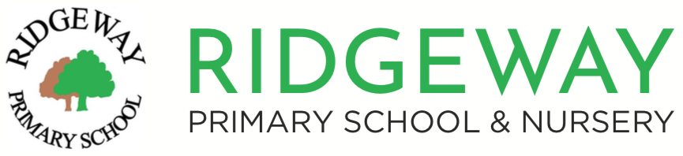

Please provide the following information to book a place on a School Tour for Reception and Nursery admissions in September 2026.

All tours start at 9:15am and will last approximately one hour.

**Date of tour:**

Monday 22nd September 2025

Tuesday 7th October 2025

Wednesday 22nd October 2025

Thursday 13th November 2025

Friday 28th November 2025

**How many adults will be attending?**

(max 2 adults)

**Name of attending adult 1:**

**Name of attending adult 2:**

(if applicable)

**Contact Phone Number:**

**Email Address:**

**Child’s Name:**

**Child’s Date of Birth:**

Please note that these tours are for **adults only – please do not bring your children with you.** We can accommodate younger siblings under one year old, provided you are able to carry them during the tour.

**Please return the completed form to** [**admissions@ridgeway.croydon.sch.uk**](mailto:admissions@ridgeway.croydon.sch.uk)